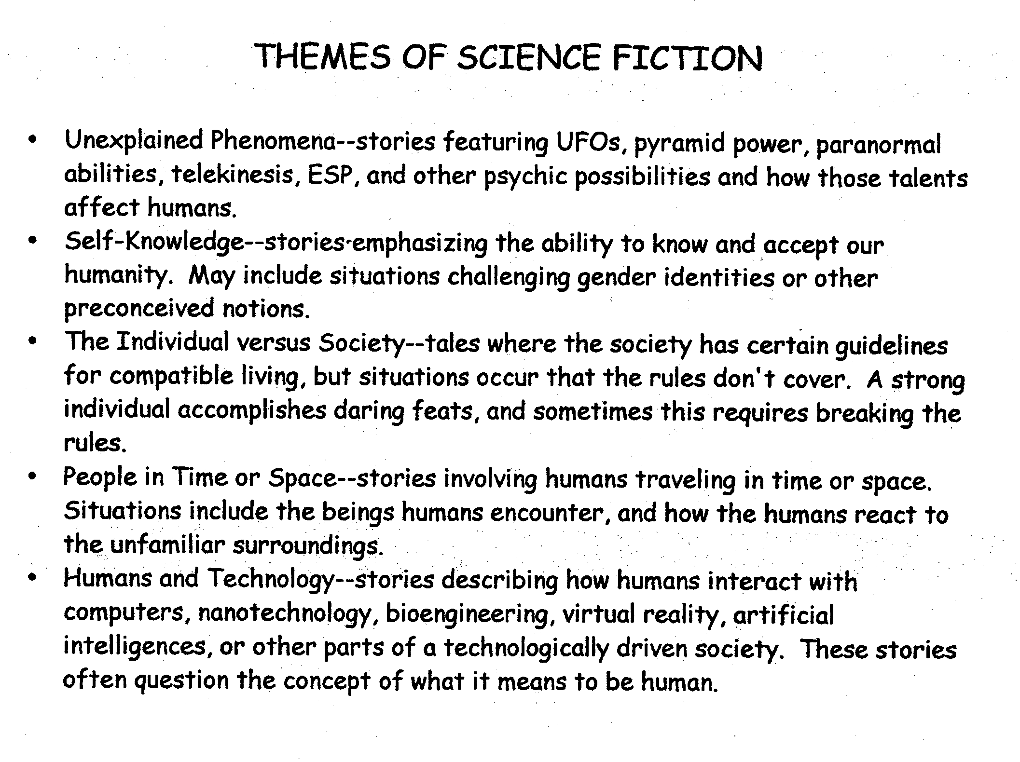
These are subjects, or motifs, common to Science Fiction stories, not fully-formed themes.

